Version Control

<Callum Wyndham> - <s220460>

Repository Links
Links:
https://github.com/CallumWyn/Classwork-2026/tree/main/Assignment 1 - Introduction to C%2B%2B - Part 1 https://github.com/CallumWyn/Classwork-2026/tree/main/Assignment%201%20-%20Introduction%20to%20C%2B%2B%20-%20Part%202
Screenshot:
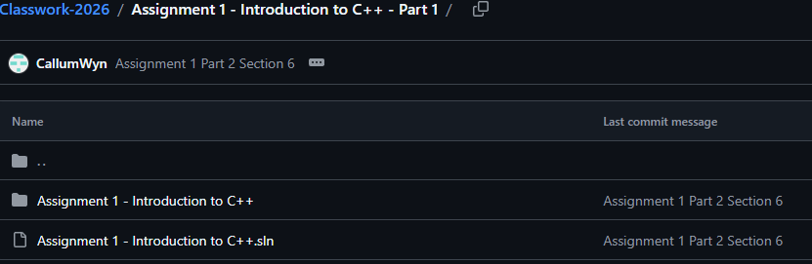
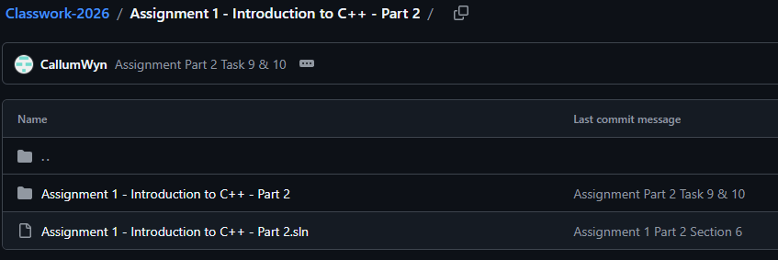

Merge Commit
Link: https://github.com/CallumWyn/Classwork-2026/pull/1/commits
Screenshot:
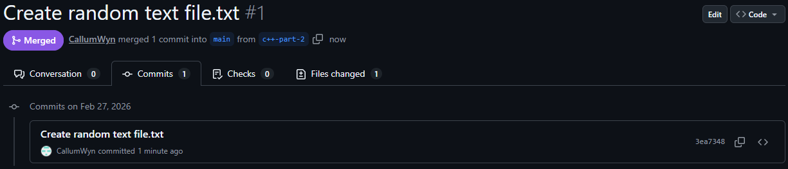

Pull Request
Link: https://github.com/CallumWyn/Classwork-2026/pull/1
Screenshot:
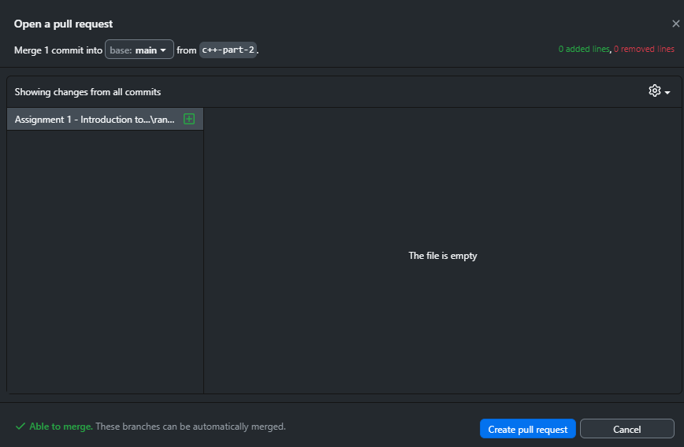

Resources:
- Visual Studio Git Ignore: https://github.com/github/gitignore/blob/main/VisualStudio.gitignore

Challenges
Write a description of the challenges, mistakes made, or problems you personally encountered, and what you did to overcome, work around, or resolve these issues. (100 - 300 words).
Honestly, the biggest challenge I faced when using version control was remembering to use it. I would finish a task, and think “Ok, cool, onto the next one”, and then I would just move onto the next task as if version control didn’t exist. After finishing a few tasks, I would realise that I needed to use version control and I made the commit and started the whole process over again. In the end, I didn’t get over this challenge and ended up committing a few tasks at once every time I made a commit. I do think I would use it more if I was more investing in what I was making, like if I spent an hour writing this cool bit of code, I would be like “That’s awesome, I’d better save it in case something happens”. I didn’t feel that way for this task because all the tasks took at most half an hour to figure out, and it would take less than 10 minutes to redo them if I lost them, so I was not inclined to do that. Another contributing factor was that I automatically save my visual studio file every time I write a couple of new lines of code, because I once lost a lot of code because I didn’t save it, and I don’t want that to happen again. So even if it does close due to unforeseen circumstances, I won’t be put too far back. The main advantage of using version control though is that you do get to go back to wherever you want if you make a mistake too big to undo, so I will work to improve on using it so if I do make a big mistake in the future, I can go back and fix it.

Weaknesses
Write a list of personal weaknesses regarding version control and ways you could resolve these weaknesses. (100 - 300 words).
As I said above, actually remembering to use version control is a big weakness of mine. If I need to go back, it undoes a bunch of code that I have written because I don’t do it often enough. I suppose the solution to getting around this is just either setting alarms every half hour or so or just to save it whenever I think about it so that I eventually get into the habit of committing it automatically, kind of like how saving visual studio files is just muscle memory now. Another thing I need to work on is actually remembering the terms of what things are related to version control. I know how to do things, and what things do, but I can’t for the life of me remember what the process of doing stuff is called. The only thing I can really remember is what committing is. Earlier in this task, I had no clue what a merge commit even was. I thought it was just a normal commit, but I wasn’t too sure how to tell the difference. Pull requests took a minute to figure out as well.

